## Gantt Chart for Technical Calculator Application

A Gantt chart provides a graphical representation tool used in project management. It helps to plan, co-ordinate and to track tasks in a project. It is outline level bar diagram. Horizontal axis represents the total time of a project and vertical axis represents the tasks that make up the project.

Benefits of using Gantt chart in Project Management.

* Manageability: For complex assignments, similar to programming distributed or occasion arranging, the advantages of Gantt graphs incorporate externalizing assignments.
* Co-ordination: It helps in coordinating team members and managers in order to make a project successful on time. Some project managers even use combinations of charts to break down projects into more manageable sets of tasks.
* Communication
* Time Management: Administrators see planning as one of the significant advantages of Gantt outlines in an innovative situation. It empowers better assignment completion.
* Efficiency
* Flexibility

**WBS diagram for Technical Calculator Application:**

**Work Breakdown Structure:** Following diagram clearly explains the work distributed across the various team members in order to complete the application successfully.

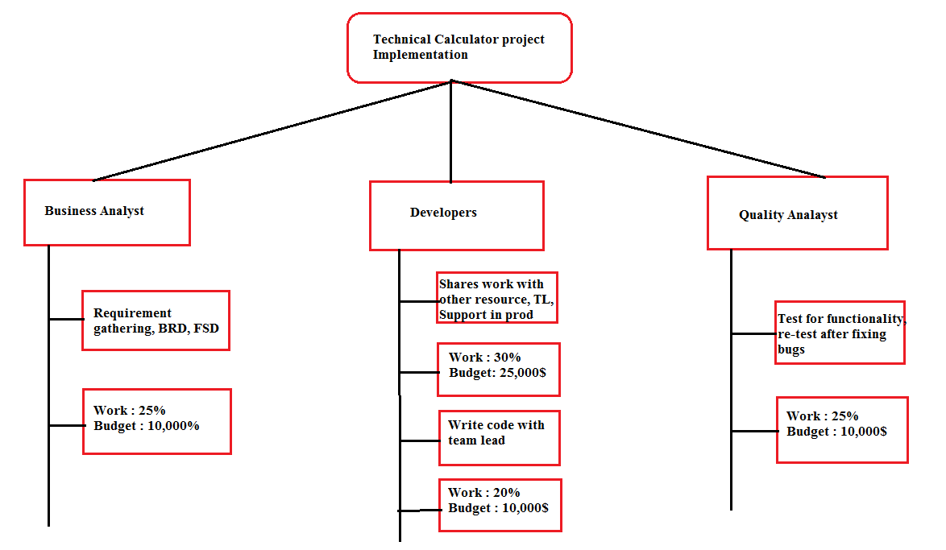

**WBS Dictionary:**

|  |  |  |
| --- | --- | --- |
| WBS No. | WBS Code | WBS Definition |
| 1 | Business Analyst | Business Analyst interacts with business users in order to gather requirements for calculator applications. This resource creates documents, user stories and assigns work to the developers and also takes day to day status calls of the project development. |
| 2 | Lead Developer | Lead Developer design, create a flow diagram, application architecture for calculator application. Also involve in coding- creating classes, methods, functions etc. Review the code of the other developer |
| 3 | Developer | Involves in coding and testing the functionality of the applications using N-unit testing. Also involves in fixing the bugs in UAT environment. |
| 4 | Quality Analyst | Test the functionality of the developed applications in all the scenarios. Create test cases in order to automate the process. Re-test the applications after bug fixing and also test for load/performance of the application. Both manual and automation testing takes place in this project. |

Algorithm:

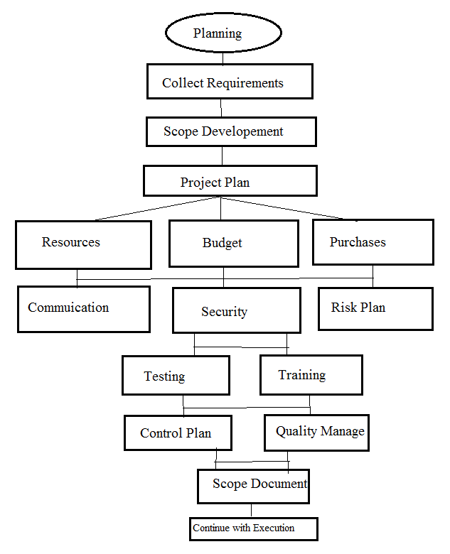

Explanation of Gantt chat containing all the Items:

1. Project Plan: A project plan for creating technical calculator is a document designed to guide the control and execution of a project. This is the key to a successful project and is the most important document that needs to be created when starting any business project. This is the first step in the project implementation. For this project the estimated time is 65 days which starts from **Sept 19th – Dec 16th**. Project manager creates the plan and make it successful by coordinating with all the team members involving in the project. Project Manager is the key member in any project.
2. Project Launch: This is the second phase of a project. After the project approval, this stage initiates the team to start up the project. This phase starts on Sept 26th and ends on Sept 27th. Project manager takes care of this phase.
3. Requirements Phase: This is the third stage in our project technical calculator. We are giving around 14 days to gather the requirements from the business users. This phase starts from Sept 28th and ends on Oct 14th. Business Analyst involves in this stage and directly interacts with the business in order to gather the requirements and drafting it. After drafting, test plan is created for 2 days. This test plan created by analyst should be approved the project manager and business, then requirements for the projects are finalized and this process takes for about 7-8 days. This business requirement document which has requirements and user stories is sent out for approval. 1st level of approver will be project manager and then business users or the clients. We are giving three days for to review and approve.

* **Draft Requirements: 09/28/2016-09/28/2016**
* **Project Test Plan: 09/29/2016-09/30/2016**
* **Acceptance Test Plan: 10/3/2016-10/3/2016**
* **Final Requirements: 10/4/2016-10/12/2016**
* **Review and Approval: 10/12/2016-10/14/2016**

1. Planning: Project planning is part of project management, which relates to the use of schedules. Initially, the project scope is defined and the appropriate methods for completing the project are determined. We are creating sub stages in planning phase. We have

* **Setup team:** We are hiring 4 team members to complete this project on time includes business analyst, developers and quality analyst. They are involved in different things in the project. This process takes around 3 days and starts from **10/17/2016-10/19/2016**
* **Setup budget:** This time is the sum of money allocated for the development of the technical calculator. Budget includes payroll for the resources, license for the software’s, maintenance, office cost and other expenses. All this process takes around 3 days and planned from **10/20/2016-10/24/2016**
* **Define Launch: 10/25/2016-10/27/2016**
* **Setup timeline:** This sub phase involves in the time of project from start to end and how to implement accordingly. This also takes three days and starts from **10/28/2016-11/01/2016**

1. Design Stage: The purpose of the design phase of project management is to manage risk effectively. The project management design phase consists of creating functional system design, creating architectural diagram, software design, interface design and specifications. This stage takes 12 days in total.

* **Architecture Diagram: 10/17/2016-10/19/2016**
* **Software Design: 10/24/2016-10/26/2016**
* **Interface Design: 10/27/2016-10/28/2016**
* **Design Specification: 10/31/2016-11/01/2016**

1. Programming Phase: This is the main phase in the project where development of the project takes place. Developers write the code based on the functionality or as per the requirements. This phase takes 22 days where it involves in the system integration, creating user classes, functions, interfaces and dev testing. After manual testing from the developers, they deploy the code into UAT for further testing from the quality analyst.

* **System Modules: 10/26/2016-11/02/2016**
* **Integrate Modules: 11/03/2016-11/15/2016**
* **Dev Testing: 11/16/2016-11/21/2016**
* **Coding complete and deploy: 11/21/2016-11/24/2016**

1. Quality Analysis: When development phase in done, code is deployed into user acceptance environment where quality analyst test the application as per functionality. This phase takes place in the period of **11/22/2016-12/09/2016.** In this period if any bugs are notified by the testing team will be sent to the development team to fix those issues. Development team will resolve the issues and deploy the latest code into UAT. Quality analyst then re-tests the code and sign off for the production.
2. Production: This is the phase comes after testing. When business users test the application in the user acceptance test environment, move the code/ deploy into production. We planned to move the project into production on **12/17/2016.**
3. Documentation: This is the phase that comes after deploying the code in to the production environment. While users using the calculator business analyst makes the documentation of whole project i.e., technical document and also users guide to how to use the application. This phase takes around 5 days ie., **12/19/2016-12/23/2016**.
4. Production Issues: This is the phase comes while using the application by the users. If any issues occurs after deploying the project, lead developer fix the issues as soon as possible and also the fixed code is deployed into the production during the weekends. This phase starts on **12/19/2016-12/23/2016.**
5. Close the Project: If all the issues are resolved the project manager closes the project on **10/26/2016.**